Enterprise Network ITNW 2350

Lab 3.1.1a

GYIMP

Jacob Calvert, Timothy Zellers, Regan Stubbs, James Baker, Faustino Gonzoles

Criteria #1: Provide screenshots that servers and client(s) is able to communicate; static IP address assigned to server. \*\* Set server name prior to installing AD

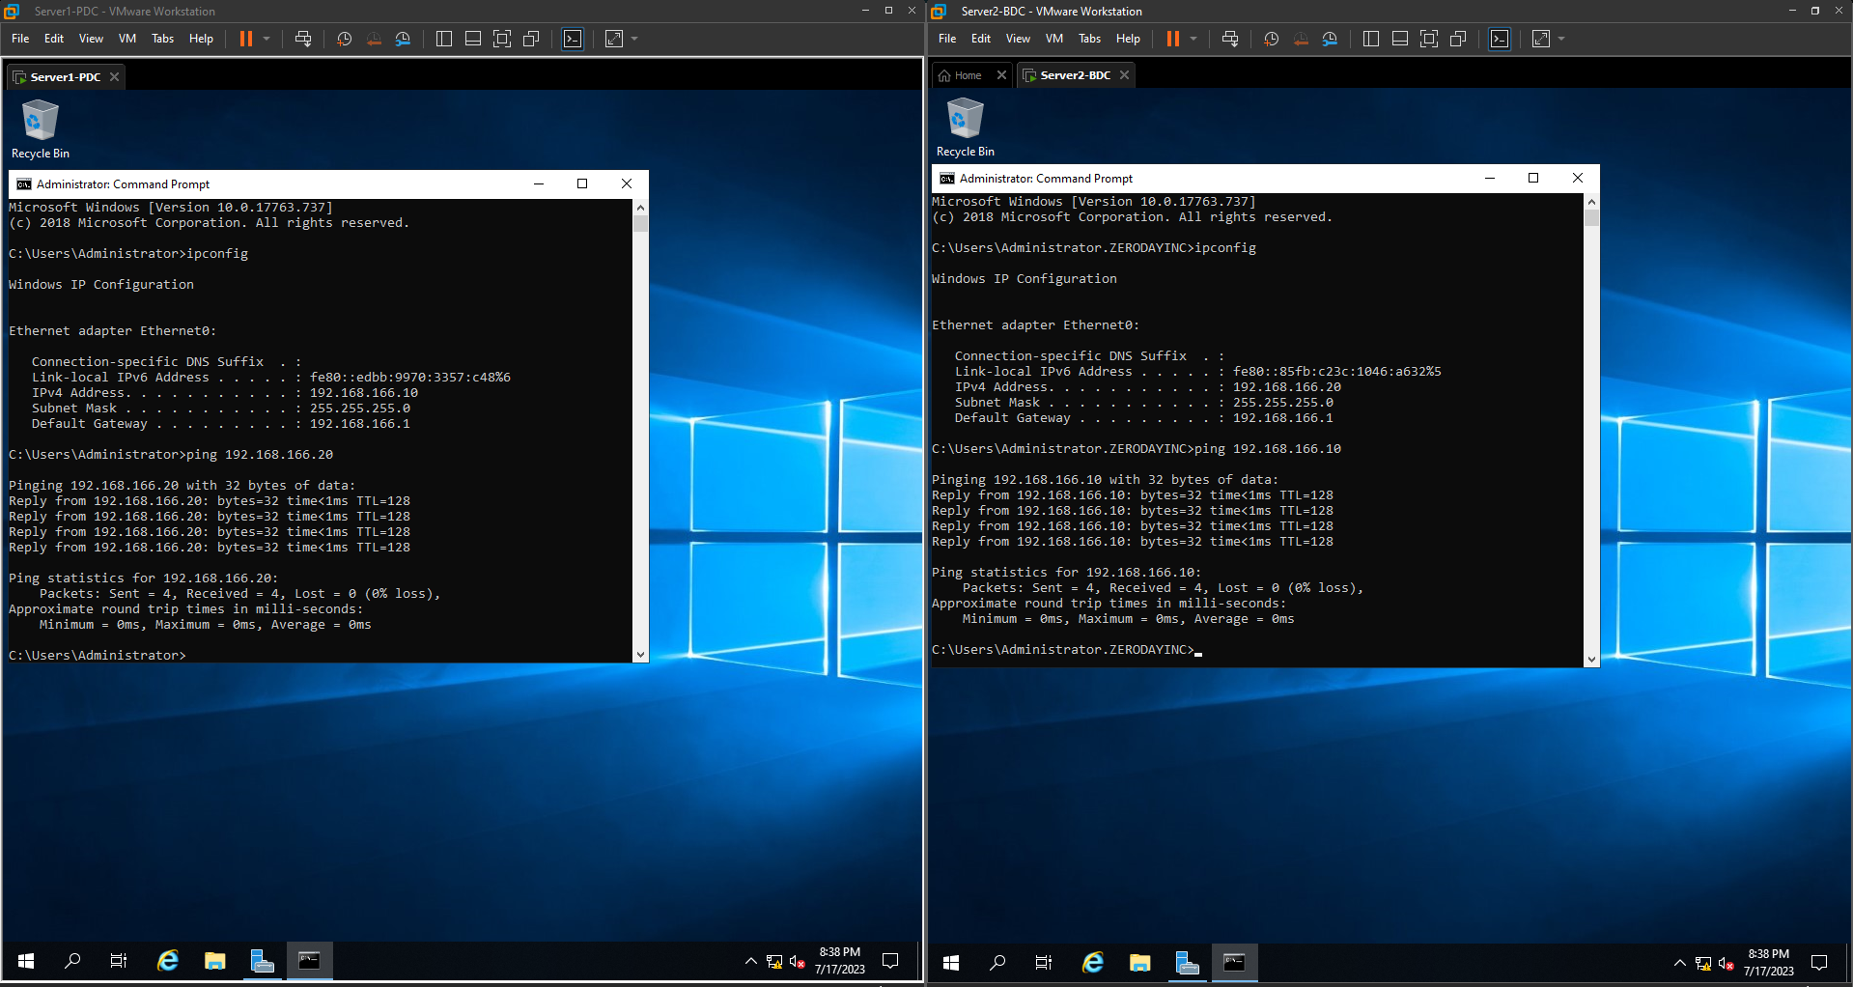

Criteria #2: AD: Provide screenshots showing AD users, groups, and OU

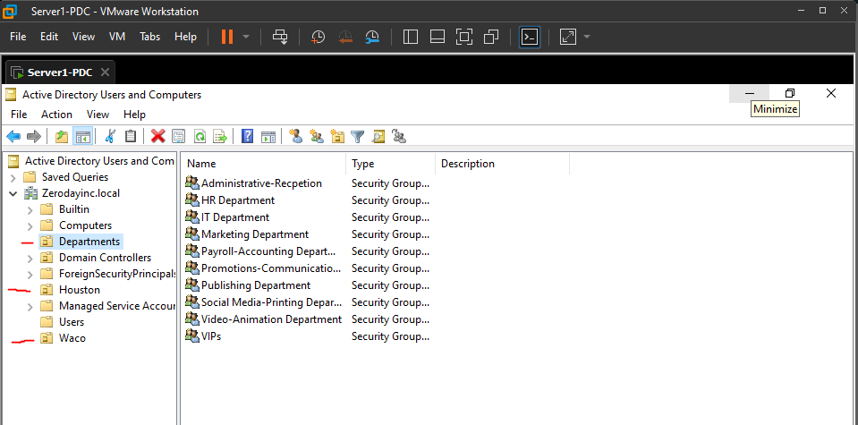

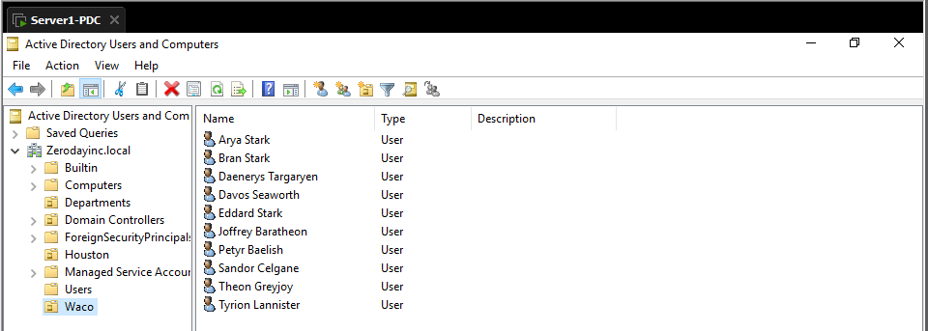

Criteria #3: GPO: Provide a print screen of domain level password policy settings. Provide evidence of GPO scope and show the details of Settings for Domain Level GPO for authentication.

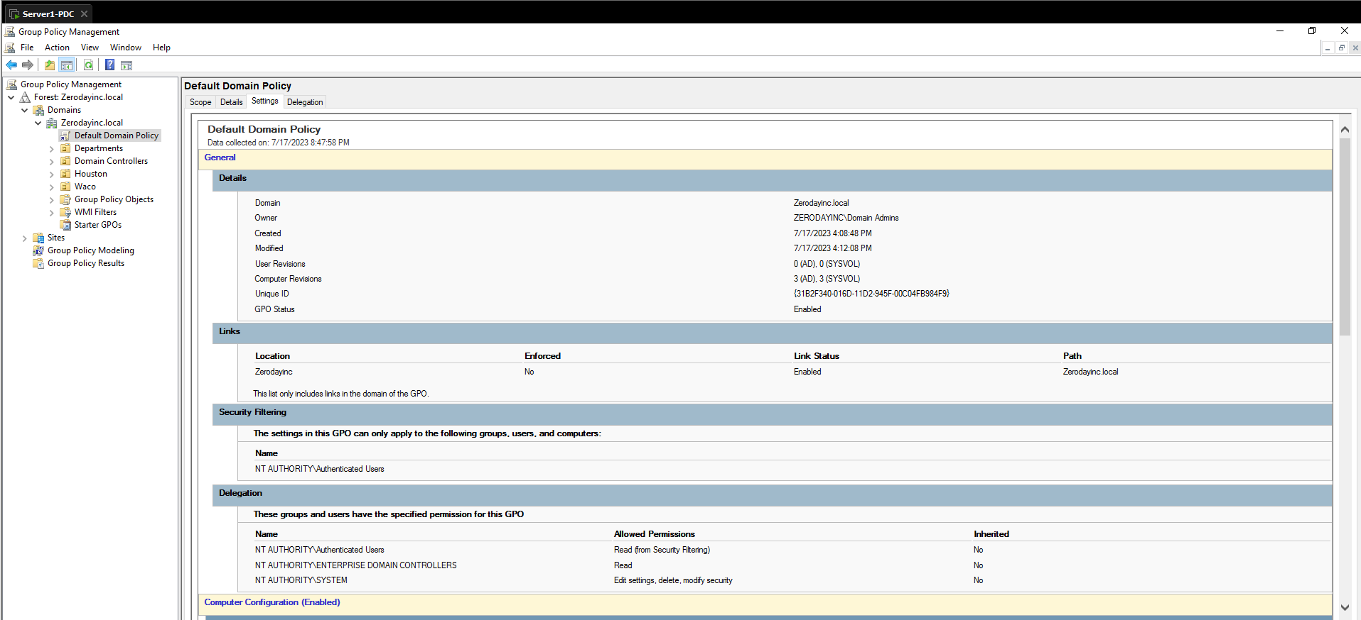

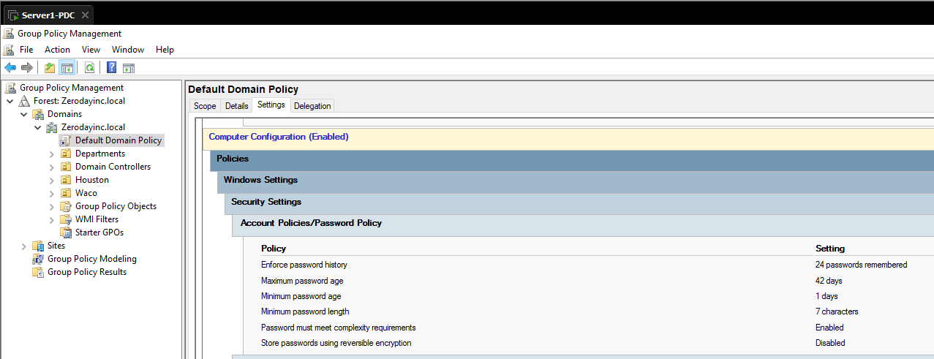

Criteria #4 DNS: Provide print screen evidence: DNS Zone Forward & Reverse zone records for NOC DNS Server

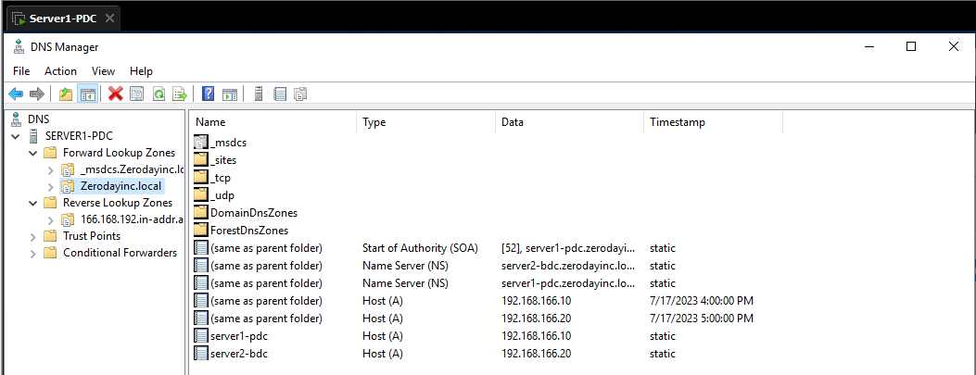

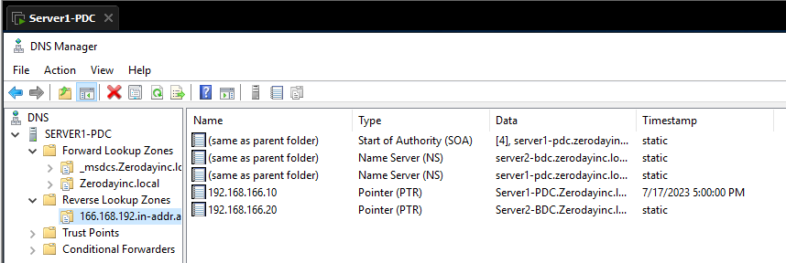

Criteria #5 DHCP: Provide print screen proof showing details for: DHCP Scope, lease duration, address exclusion, and Options: DNS & Gateway Note: Save Client Lease proof for later submission

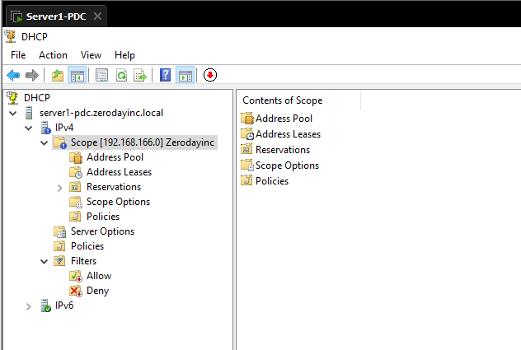

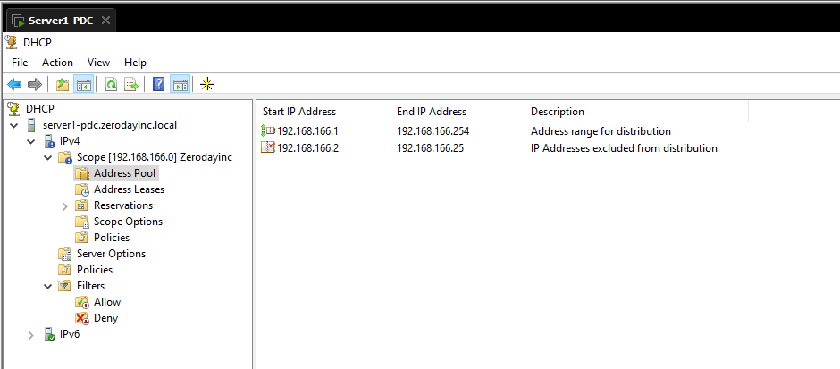

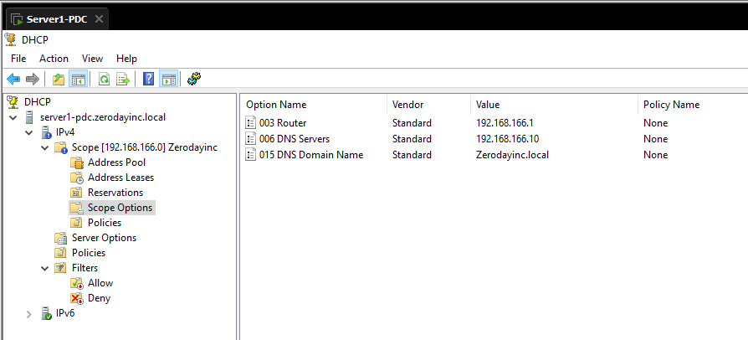

Criteria #6 Backups: Provide print screen evidence backups scheduled and successfully performed. Note: Successful proof should include the # of files and backup size. Note: It’s possible to receive “successful message with zero data backed up”.

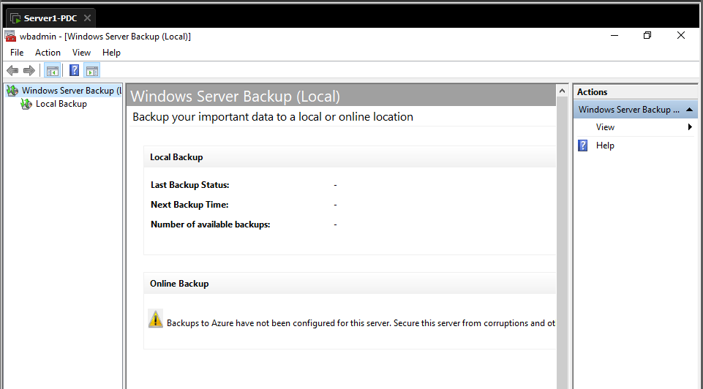

Criteria #7 Fault Tolerance AD: Provide evidence two DC. (AD Users & Computers - “Domain Controllers” objects)

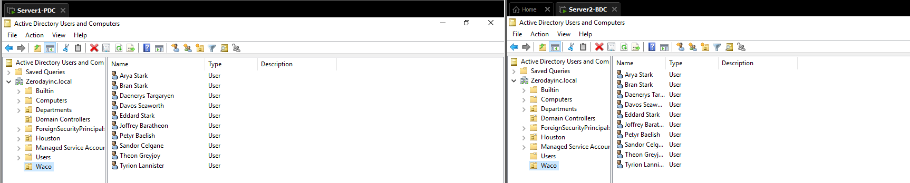

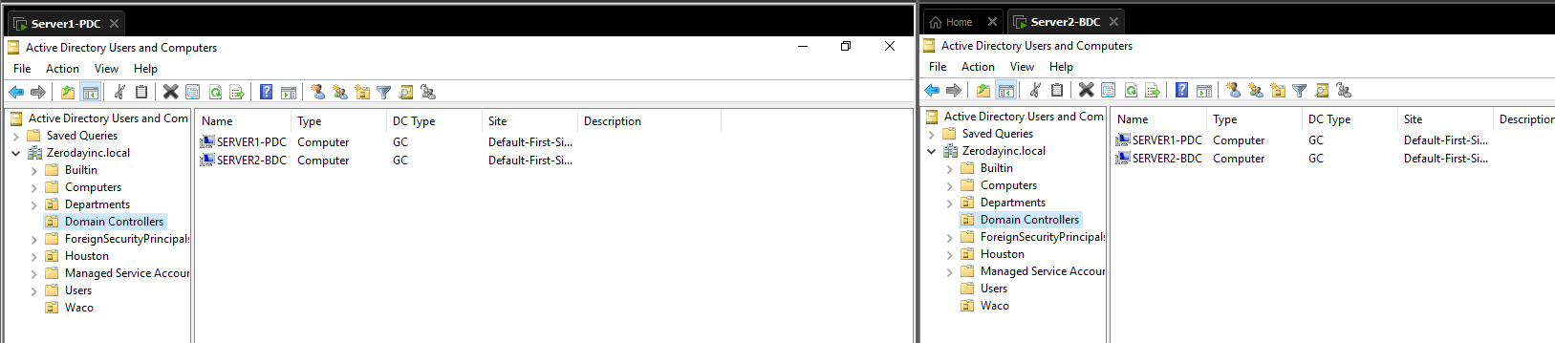

Criteria #8 Fault Tolerance DNS Master / Secondary: 1) Provide print screen evidence zone transfer setting from Master DNS & Secondary DNS server (DMZ). 2) Provide evidence show secondary DNS server received transfer of both forward & reverse zone records